INDIVIDUAL FOOTPRINT
Student Information
Name: Nguyen Anh Thu
Student ID: 2312380036
Project: PortTrack – Virtual Portfolio Trading Platform
Group: 5
Role: Team Leader & Database Coordinator
- Overview of My Contribution
In this project, I was responsible for being the team leader and coordinating team activities as well as supporting database-related tasks. My main contribution was ensuring consistency between the database design and backend implementation while helping the team maintain progress throughout the development process.
The database structure I reviewed and refined serves as the foundation for core functionalities such as user authentication, room management, portfolio tracking, transaction history, and ranking calculations.
- Work Completed
  - Business Workflow and Database Analysis
I first analyzed the overall flow of the PortTrack system to understand how users, rooms, portfolios, holdings, transactions, and rankings interact with each other.
Based on these requirements, I reviewed and refined the database structure, relationships, keys, and constraints to ensure that the system data model could support all major functionalities.
  - Database and Backend Consistency Verification
I compared the database schema with backend entity and repository classes to verify consistency between the data model and application logic.
This included:
- Reviewing table structures and relationships.
- Checking entity-to-table mappings.
- Reviewing repository classes for data retrieval and storage.
- Validating foreign key relationships and constraints.
  - Database Testing and Validation
I reviewed MySQL tables and performed validation to ensure data integrity.
Activities included:
- Checking table relationships.
- Reviewing foreign key constraints.
- Testing data insertion and retrieval.
- Verifying consistency between related tables.
  - Team Coordination
As Team Leader, I monitored progress, coordinated task allocation, followed up on deadlines, and helped resolve integration issues between different modules. I also worked on the techflow and workflow of my team.
I also contributed to preparing project documentation and final submission materials.
- Evidence of Contribution
The following evidence demonstrates my contribution to the project.
  - Evidence 1: Database Structure and Design
Files:
- CREATE_TABLE.TXT
- Cấu trúc dữ liệu.txt
Contribution:
Reviewed and refined database tables, relationships, primary keys, foreign keys, and constraints to support the project's business requirements.
  - Evidence 2: Backend Verification
Files:
- entity/
- repository/
Contribution:
Reviewed entity classes and repository classes to ensure consistency between the database design and backend implementation.
  - Evidence 3: Database Validation
Contribution:
Verified data integrity and table relationships through MySQL testing and query validation.
I have:
- Checked portfolio data retrieval.
- Verified transaction records.
- Tested foreign key relationships.
  - Evidence 4: Team Coordination
Evidence: Group task allocation and progress tracking spreadsheet.
Contribution:
- Assigned and monitored tasks.
- Followed up on deadlines.
- Coordinated communication between members.
- Supported integration and final delivery.
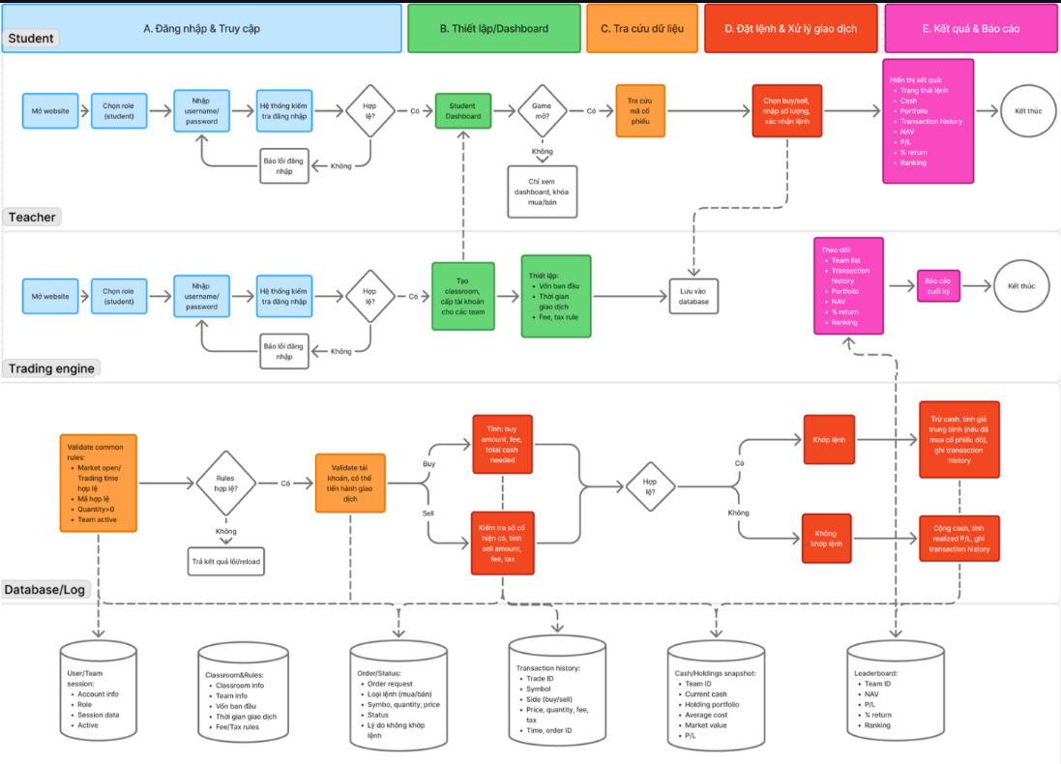
Figure 1: Group’s techflow
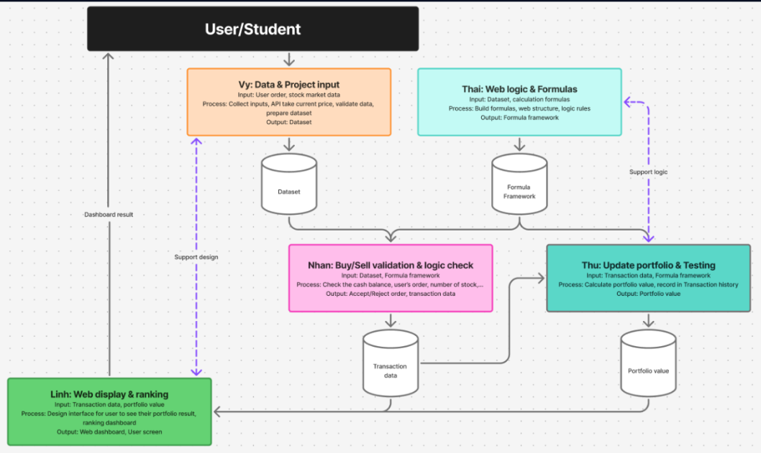
Figure 2: Group’s workflow
  - Evidence 5: Documentation and Final Submission
Files:
- README.md
- Submission documents
Contribution:
Updated documentation and prepared materials required for project submission and evaluation.
- Impact on the Final Product
My contribution mainly supported the project's data layer and team coordination process.
The reviewed database structure enables:
- User authentication
- Trading room management
- Portfolio management
- Transaction recording
- NAV calculation
- Ranking functionality
In addition, project coordination helped ensure that frontend, backend, and database components were successfully integrated into a functional product.
- Lessons Learned
This project gave me practical experience working on a complete software system rather than isolated programming exercises.
From a technical perspective, I learned how business requirements are translated into a relational database structure and how different components of a system depend on consistent data design. I also became more familiar with reading source code, reviewing entity relationships, testing databases, and understanding how backend applications interact with stored data.
As Team Leader, I learned that project success depends not only on technical skills but also on communication and coordination. Tracking progress regularly, clarifying responsibilities, and identifying issues early helped the team work more efficiently.
Another important lesson was learning how to use AI tools effectively. AI was useful for understanding unfamiliar concepts, generating ideas, and speeding up learning. However, I realized that every AI-generated suggestion must be verified through project requirements, source code, and testing results before being applied.
Overall, this project improved both my technical understanding and my ability to collaborate within a software development team.
- Message for Future Students
Start by understanding the overall workflow of the system before focusing on implementation details. A clear understanding of the data model and business process will make development and integration much easier.
AI can be a valuable learning tool, but it should be used to support understanding rather than replace it. Always verify outputs through testing and actual project requirements.
Most importantly, maintain clear communication within the team and keep documentation updated throughout the project.

